React Initial Setup

### Step 1: Install Node.js

Website: <https://nodejs.org/en>

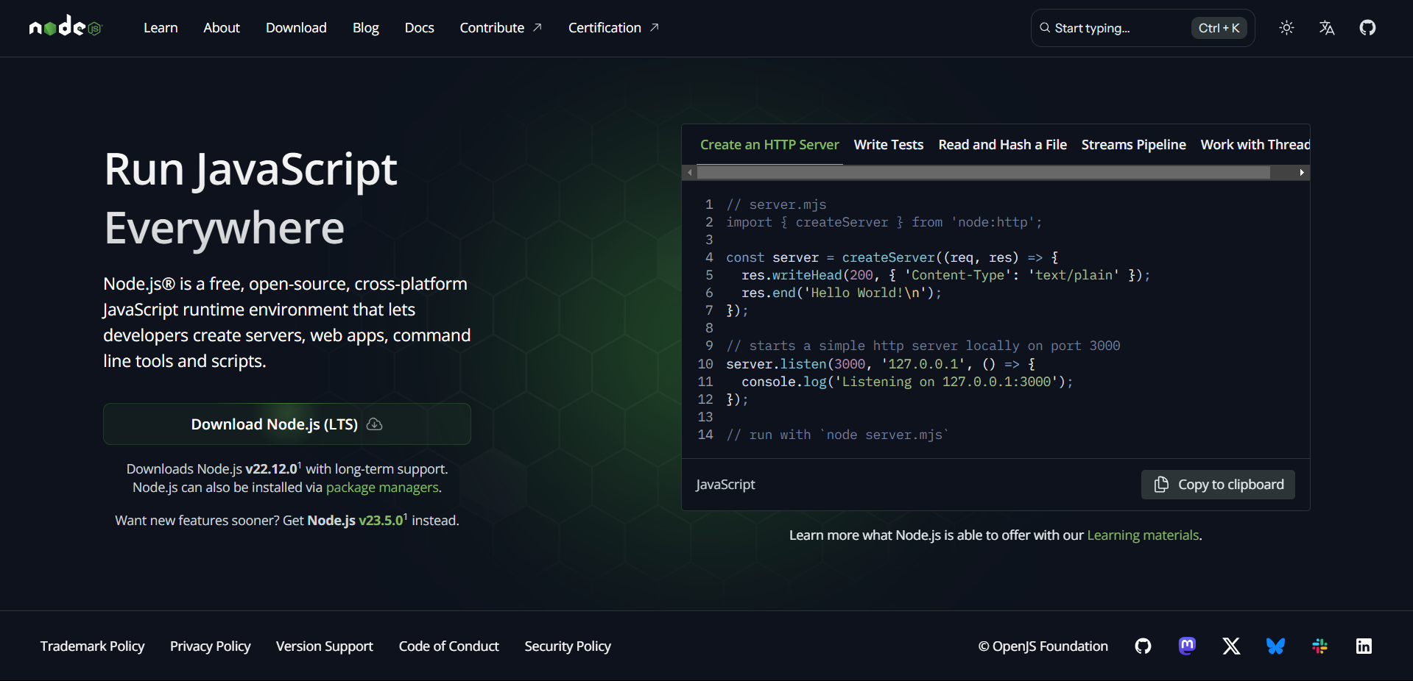

### Step 1.1: Confirm that Node has been successfully installed.

#### Type in node -v in your command prompt, then click the enter button.

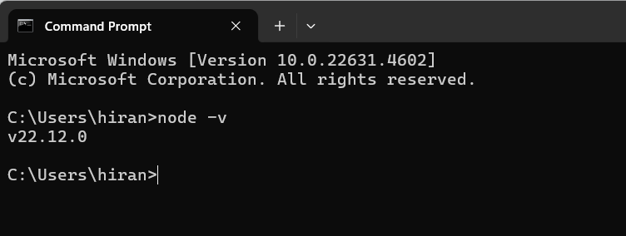

### Step 2: Create a folder for the project

#### Open the folder in VScode

#### Open a new terminal in VScode (Ctrl+Shift+`)

#### Run the command for creating a react app in that folder

#### In the newly created folder directory,

#### type in

#### npx create-react-app [project name of your choice]

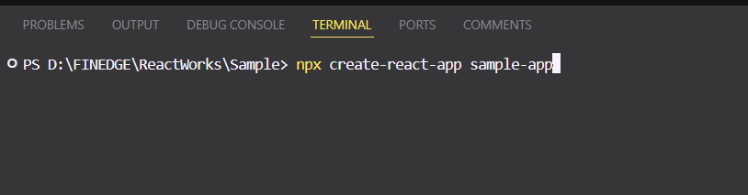

#### After creating app, the folder will look like this

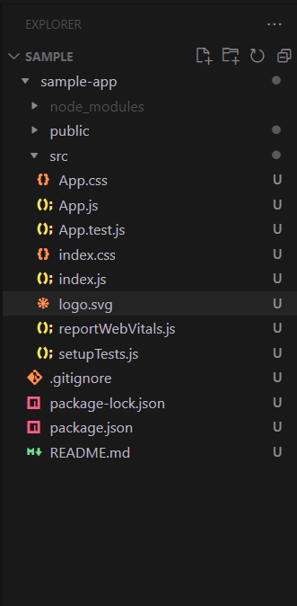

In the above image, let's go over some of the elements you'll see there.

* The node modules folder is a storage folder that holds your React package along with other packages that might be installed as you work on your React project. The node module helps configure the design system of your React project.
* The src folder stores in all the files and components used in your react application ranging from the App.js, index.js, App.css just as seen in the image above.
* The package-lock.json file locks the versions of dependencies your React project uses, and this helps in managing dependencies in your React project.

### Step 3: Navigate to the created app in the folder

#### cd sample-app

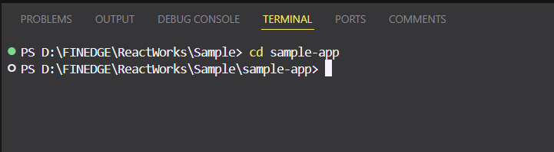

### Step 4: For running the app, in terminal type :

#### npm start

#### If this error occurs

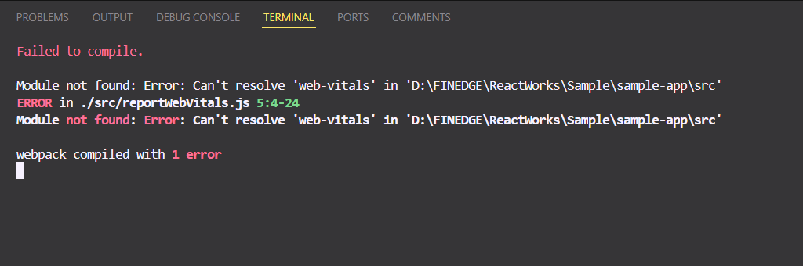

#### In terminal type :

#### npm install web-vitals

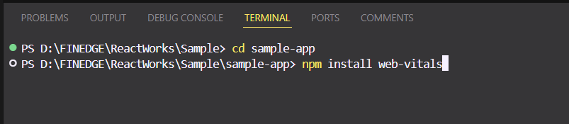

#### After installing web-vitals, again type npm start for running the app

### If everything is okay, the terminal will look like this,

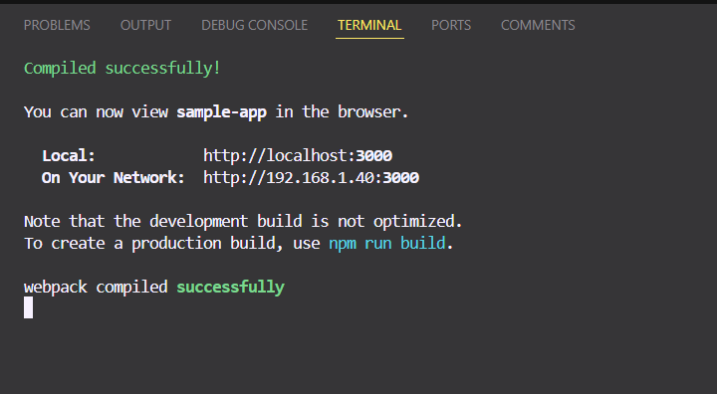

#### Now for opening the app,

#### Ctrl+click on localhost link

#### It will redirect to the browser and will look like this

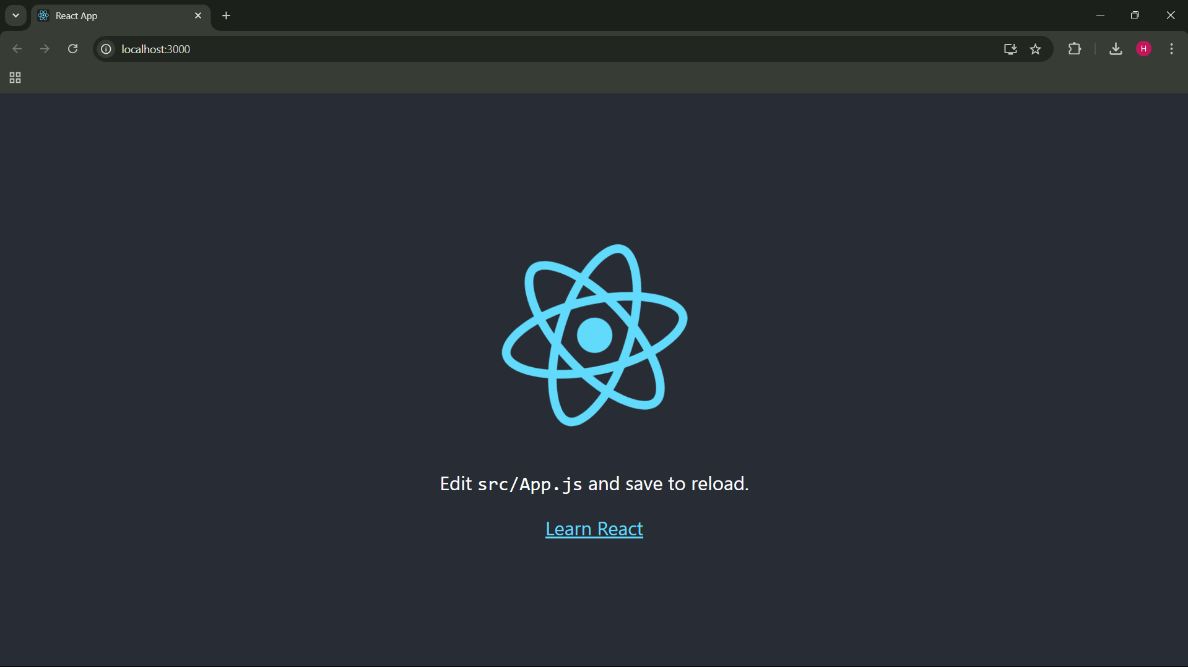

Now you can edit the App.js file